COSHH Risk Assessment No: 00
Product Name: 4.5G HAZ-TAB Tablets
Company name: Guest Medical Limited |  |  |  |  |  |  |  | Dept. (if applicable): N/A
Describe the activity or work process.  (Inc. how long/ how often this is carried out and quantity substance used) |  |  | Used as a part of a spill kit
Location of process being carried out? |  |  | All areas
Identify the persons at risk: |  |  |  | Employees  X |  |  |  |  | Sub-contractors |  | Public
Name the substance involved in the process and its manufacturer.  (A copy of a current safety data sheet is attached to this assessment) |  |  |  | 4.5G HAZ-TAB Tablets  Guest Medical Limited Unit A6, Larkfield Trading Estate, New Hythe Lane, Aylesford. Kent. ME20 6SW
Classification (state the category of danger)
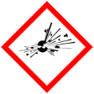 |  | Explosive | 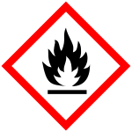 |  | Flammable | 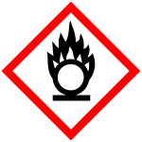 |  | Oxidising
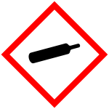 |  | Gas under pressure | 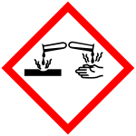 |  | Corrosive | 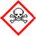 |  | Acute Toxic
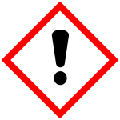 | X | Harmful / Irritant / Skin Sensitiser | 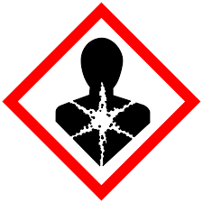 |  | Carcinogen / Germ Cell Mutagen / Reproductive Toxin | 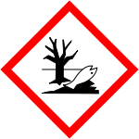 | X | Hazardous to the Aquatic Environment

Hazard Type
X

Gas Vapour Mist Fume Dust Liquid Solid Other (State)
Route of Exposure
X
X
X
X

Inhalation Skin Eyes Ingestion Other (State)
Workplace Exposure Limits (WELs) please indicate n/a where not applicable
Long-term exposure level (8hrTWA):  10 mg/m3 inhalable dust 4.0 mg/m3 respirable dust |  |  |  |  |  |  | Short-term exposure level (15 mins):  (as Chlorine) 0.5 ppm 1.5mg/m3 fume
State the Risks to Health from Identified Hazards
EC

H302 Harmful if swallowed. H319 Causes serious eye irritation. H335 May cause respiratory irritation. H410 Very toxic to aquatic life with long lasting effects.

P271 Use only outdoors or in a well-ventilated area. P273 Avoid release to the environment. P280 Wear protective gloves/protective clothing/eye protection/face protection. P301+P310 IF SWALLOWED; immediately call a doctor P337+P313 If eye irritation persists: Get medical advice/attention. P402+P404 Store in a dry place. Store in a closed container. P501 Dispose of contents/container in accordance with local regulations.

P264 Wash hands thoroughly after handling. P304+P340 IF INHALED: Remove person to fresh air and keep comfortable for breathing. P305+P351+P338 IF IN EYES: Rinse cautiously with water for several minutes. Remove contact lenses, if present and easy to do. Continue rinsing. P312 Call a doctor if you feel unwell P391 Collect spillage P403+P233 Store in a well-ventilated place. Keep container tightly closed.

Control Measures:
Use in well ventilated areas

Is health surveillance or monitoring required?
X

Yes No

Personal Protective Equipment (state type and standard)
Dust mask |  |  |  |  |  | Visor
Respirator |  | Use in a well-ventilated area |  |  |  | Goggles
Gloves |  | No specific hand protection recommended. For prolonged or repeated skin contact use suitable protective gloves. |  |  |  | Overalls
Footwear |  |  |  |  |  | Other
First Aid Measures
Inhalation

Move the exposed person to fresh air at once. Provide rest, warmth and fresh air.

Ingestion

Rinse mouth thoroughly. Get medical attention.

Skin Contact

Wash the skin immediately with soap and water. Get medical attention if irritation persists after washing.

Eye Contact

Make sure to remove any contact lenses from the eyes before rinsing. Promptly wash eyes with plenty of water while lifting the eye lids. Continue to rinse for at least 15 minutes. Get medical attention if any discomfort continues.

Storage
Keep only in the original container in a cool, well-ventilated place.

Disposal of Substances & Contaminated Containers
X

Hazardous Waste Skip Return to Depot Return to Supplier Other

(If Other Please State):
Is exposure adequately controlled? |  |  |  |  | X  Yes No
Risk Rating Following Control Measures
X

High Medium Low

Assessed by: Pete Reynolds Date: Review Date:

