COSHH Risk Assessment No: 00
Product Name: Clinell Universal Wipes
Company name: Gama Healthcare Ltd. |  |  |  |  |  |  |  | Dept. (if applicable): N/A
Describe the activity or work process.  (Inc. how long/ how often this is carried out and quantity substance used) |  |  | Cleaning & Disinfectant Wipes
Location of process being carried out? |  |  | Within the building
Identify the persons at risk: |  |  |  | Employees  X |  |  |  |  | Sub-contractors |  | Public
Name the substance involved in the process and its manufacturer.  (A copy of a current safety data sheet is attached to this assessment) |  |  |  | Clinell Universal Wipes  GAMA Healthcare Ltd Unit 2, The Exchange Brent Cross Gardens London NW4 3RJ
Classification (state the category of danger)
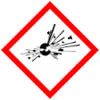 |  | Explosive | 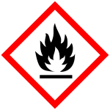 | X | Flammable | 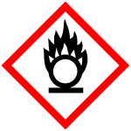 |  | Oxidising
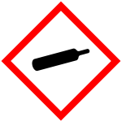 |  | Gas under pressure | 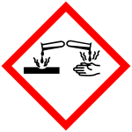 |  | Corrosive | 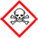 |  | Acute Toxic
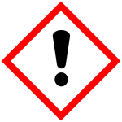 | X | Harmful / Irritant / Skin Sensitiser | 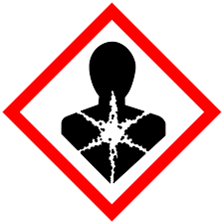 |  | Carcinogen / Germ Cell Mutagen / Reproductive Toxin | 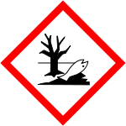 |  | Hazardous to the Aquatic Environment

Hazard Type
X

X

Gas Vapour Mist Fume Dust Liquid Solid Other (State)
Route of Exposure
X
X
X
X

Inhalation Skin Eyes Ingestion Other (State)
Workplace Exposure Limits (WELs) please indicate n/a where not applicable
Long-term exposure level (8hrTWA): |  |  |  |  |  |  | Short-term exposure level (15 mins):
State the Risks to Health from Identified Hazards
EC

R21: harmful in contact with skin, R22: harmful if swallowed, R34: Cause burns, R50: Very toxic to aquatic organisms. R50-53: Very toxic to aquatic organisms, may cause long term adverse effects in the aquatic environment.

H302: harmful if swallowed, H312: harmful in contact with skin, H314: causes severe skin burns and eye damage, H315: causes skin irritation, H317: may cause an allergic skin reaction, H400: very toxic to aquatic life, H410: very toxic to aquatic life with long lasting effects

Control Measures:
Use in well ventilated areas

Is health surveillance or monitoring required?
X

Yes No

Personal Protective Equipment (state type and standard)
Dust mask |  |  |  |  |  | Visor
Respirator |  |  |  |  |  | Goggles |  |  |  | Avoid contact with eyes.
Gloves |  |  |  |  |  | Overalls
Footwear |  |  |  |  |  | Other
First Aid Measures
Inhalation

Remove victim to fresh air and keep at rest. Get medical attention if adverse health effects persist or are severe.

Ingestion

Wash out mouth with water. Do not induce vomiting. Get medical attention if adverse health effects persist or are severe.

Skin Contact

Wash the skin immediately with soap and water. Get medical attention if irritation persists after washing.

Eye Contact

Make sure to remove any contact lenses from the eyes before rinsing. Promptly wash eyes with plenty of water while lifting the eye lids. Continue to rinse for at least 15 minutes. Get medical attention if any discomfort continues.

Storage
Store in a cool, dry, well-ventilated place, away from direct sunlight. Do not allow to freeze. Keep container closed when not in use.

Disposal of Substances & Contaminated Containers
X

Hazardous Waste Skip Return to Depot Return to Supplier Other

(If Other Please State):
Is exposure adequately controlled? |  |  |  |  | X  Yes No
Risk Rating Following Control Measures
X

High Medium Low

Assessed by: Pete Reynolds Date: Review Date:

