COSHH Risk Assessment No:
Product Name: MR MUSCLE Window & Glass Cleaner
Company name: SC Johnson Ltd |  |  |  |  |  |  |  | Dept. (if applicable): N/A
Describe the activity or work process.  (Inc. how long/ how often this is carried out and quantity substance used) |  |  | Used as a window cleaner
Location of process being carried out? |  |  | All areas
Identify the persons at risk: |  |  |  | Employees  X |  |  |  |  | Sub-contractors |  | Public
Name the substance involved in the process and its manufacturer.  (A copy of a current safety data sheet is attached to this assessment) |  |  |  | MR MUSCLE Window & Glass Cleaner  SC Johnson Ltd. Frimley Green Camberley Surrey GU16 7AJ
Classification (state the category of danger)
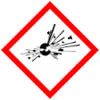 |  | Explosive | 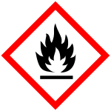 |  | Flammable | 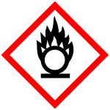 |  | Oxidising
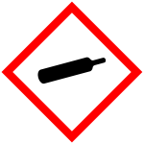 |  | Gas under pressure | 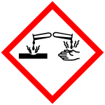 |  | Corrosive | 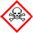 |  | Acute Toxic
 | X | Harmful / Irritant / Skin Sensitiser | 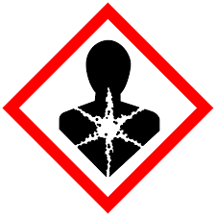 |  | Carcinogen / Germ Cell Mutagen / Reproductive Toxin | 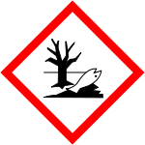 | X | Hazardous to the Aquatic Environment

Hazard Type
X

X
X

Gas Vapour Mist Fume Dust Liquid Solid Other (State)
Route of Exposure
X
X
X
X

Inhalation Skin Eyes Ingestion Other (State)
Workplace Exposure Limits (WELs) please indicate n/a where not applicable
Long-term exposure level (8hrTWA):  Propan-2-ol 999 mg/m3 - 400 ppm |  |  |  |  |  |  | Short-term exposure level (15 mins):  Propan-2-ol 1250 mg/m3 - 500 ppm
State the Risks to Health from Identified Hazards
EC Classification:

R11 Highly flammable. R36 Irritating to eyes. R67 Vapours may cause drowsiness and dizziness.

S2 Keep out of the reach of children. S23 Do not breathe spray. S26 In case of contact with eyes, rinse immediately with plenty of water and seek medical advice. S51 Use only in well-ventilated areas.

Control Measures:
Use in well ventilated areas

Is health surveillance or monitoring required?
X

Yes No

Personal Protective Equipment (state type and standard)
Dust mask |  |  |  |  |  | Visor
X  Respirator |  |  |  |  |  | Goggles |  |  |  | Avoid contact with eyes
Gloves |  | Wear protective gloves if in prolonged contact with substance |  |  |  | Overalls
X  Footwear |  |  |  |  |  | Other
First Aid Measures
Inhalation:

Skin:

Wash with plenty of water.

Eyes:

Rinse immediately with plenty of water. Remove any contact lenses and open eyelids wide apart. Continue to rinse for at least 15 minutes. Get medical attention if any discomfort continues.

Ingestion:

Do not induce vomiting. Give plenty of water to drink. Get medical attention if any discomfort continues.

Storage
Storage:

Avoid contact with skin and eyes. Avoid breathing vapour.

Storage Store in a cool dry area out of direct sunlight.

Disposal of Substances & Contaminated Containers
X

Hazardous Waste Skip Return to Depot Return to Supplier Other

(If Other Please State):
Is exposure adequately controlled? |  |  |  |  | X  Yes No
Risk Rating Following Control Measures
X

High Medium Low

Assessed by: Pete Reynolds Date: Review Date:

