COSHH Risk Assessment No: 00
Product Name: Mercury
Company name: Various Suppliers |  |  |  |  |  |  |  | Dept. (if applicable): N/A
Describe the activity or work process.  (Inc. how long/ how often this is carried out and quantity substance used) |  |  | Used in Blood Pressure Monitors
Location of process being carried out? |  |  | Examination Rooms
Identify the persons at risk: |  |  |  | Employees  X |  |  |  |  | Sub-contractors |  | Public  X
Name the substance involved in the process and its manufacturer.  (A copy of a current safety data sheet is attached to this assessment) |  |  |  | Mercury  Various Suppliers
Classification (state the category of danger)
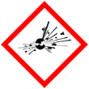 |  | Explosive | 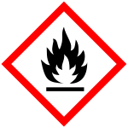 |  | Flammable | 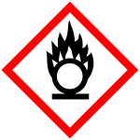 |  | Oxidising
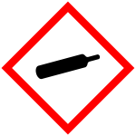 |  | Gas under pressure | 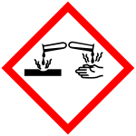 | X | Corrosive | 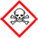 | X | Acute Toxic
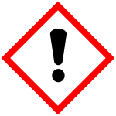 |  | Harmful / Irritant / Skin Sensitiser | 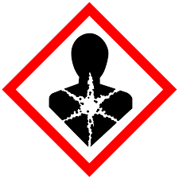 | X | Carcinogen / Germ Cell Mutagen / Reproductive Toxin | 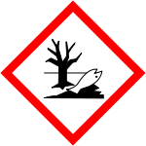 | X | Hazardous to the Aquatic Environment

Hazard Type
X

X

X

Gas Vapour Mist Fume Dust Liquid Solid Other (State)
Route of Exposure
X
X
X
X

Inhalation Skin Eyes Ingestion Other (State)
Workplace Exposure Limits (WELs) please indicate n/a where not applicable
Long-term exposure level (8hrTWA):  0.02 mg/m3 |  |  |  |  |  |  | Short-term exposure level (15 mins):
State the Risks to Health from Identified Hazards
EC Classification:

H290 May be corrosive to metals. H330 Fatal if inhaled. H317 May cause allergic skin reaction. H360 May damage fertility or the unborn child. H372 Causes damage to organs through prolonged or repeated inhalation exposure.

P201 Obtain special instructions before use. P202 Do not handle until all safety precautions have been read and understood. P234 Keep only in original container. P260 Do not breathe fumes, mists, vapours, or spray. P264 Wash hands thoroughly after handling. P270 Do not eat, drink or smoke when using this product. P271 Use only outdoors or in a well-ventilated area. P284 In case of inadequate ventilation, wear respiratory protection. P272 Contaminated work clothing must not be allowed out of the workplace. P280 Wear protective gloves, protective clothing, and eye protection. P304+P340 If inhaled: Remove person to fresh air and keep comfortable for breathing. P310 Immediately call a doctor. P302+P352 If on skin: Wash with plenty of water. P333+P313 If skin irritation or rash occurs: Get medical attention. P308+P313 If exposed or concerned: Get medical attention. P363 Wash contaminated clothing before reuse. P390 Absorb spillage to prevent material damage. P403+P233 Store in a well-ventilated place. Keep container tightly closed. P405 Store locked up. P406 Store in corrosive resistant container or a container with a resistant inner liner. P501 Dispose of contents and container according to local regulations

Control Measures:
Use in well ventilated areas

Is health surveillance or monitoring required?
X

Yes No

Personal Protective Equipment (state type and standard)
Dust mask |  |  |  |  |  | Visor
X  X  Respirator |  | Must be worn if the situation dictates |  |  |  | Goggles |  |  |  | Must be worn if the situation dictates
X  X  Gloves |  | Must be worn if the situation dictates |  |  |  | Overalls |  |  |  | Must be worn if the situation dictates
Footwear |  |  |  |  |  | Other
First Aid Measures
Inhalation:
If adverse effects occur, remove to uncontaminated area. If not breathing, give artificial respiration or oxygen by qualified personnel. Seek immediate medical attention.

Skin:
Wash skin with soap and water for at least 15 minutes while removing contaminated clothing and shoes. Get immediate medical attention. Thoroughly clean and dry contaminated clothing before reuse. Destroy contaminated shoes

Eyes:
Immediately flush eyes, including under the eyelids with copious amounts of water for at least 15 minutes. Seek immediate medical attention

Ingestion:

Contact a poison control centre immediately for instructions. If vomiting occurs, keep head lower than hips to prevent aspiration. Seek immediate medical attention.

Storage
Storage: Store and handle in accordance with all current regulations and standards. Keep separated from incompatible substances

Conditions to Avoid: Contact with combustible or incompatible materials. Incompatible Materials: Acids, combustible materials, amines, oxidizing materials, metals, halogens, metal carbide.

Extinguishing Media: Suitable: Regular dry chemical, carbon dioxide, water, regular foam.

Methods and Materials for Containment and Clean up: Do not touch spilled material. Notify safety personnel of spills. Absorb with sand or other non-combustible material. Collect spilled material in appropriate container for disposal. Isolate hazard area and deny entry, wear appropriate Personal Protective Equipment (PPE) to minimize exposure to this material

Disposal of Substances & Contaminated Containers
X

X

Hazardous Waste Skip Return to Depot Return to Supplier Other

(If Other Please State):
Is exposure adequately controlled? |  |  |  |  | X  Yes No
Risk Rating Following Control Measures
X

High Medium Low

Assessed by: Pete Reynolds Date: Review Date:

