COSHH Risk Assessment No: 010
Product Name: Harpic Power Plus
Company name: Reckitt Benckiser |  |  |  |  |  |  |  | Dept. (if applicable): N/A
Describe the activity or work process.  (Inc. how long/ how often this is carried out and quantity substance used) |  |  | Used as a cleaning agent
Location of process being carried out? |  |  | All areas
Identify the persons at risk: |  |  |  | Employees  X |  |  |  |  | Sub-contractors |  | Public
Name the substance involved in the process and its manufacturer.  (A copy of a current safety data sheet is attached to this assessment) |  |  |  | Harpic Power Plus  Reckitt Benckiser Wellcroft House Wellcroft Road Slough, Berkshire SL1 4AQ Tel 0845 769 7079
Classification (state the category of danger)
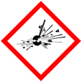 |  | Explosive | 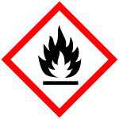 |  | Flammable | 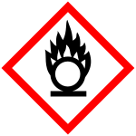 |  | Oxidising
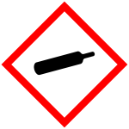 |  | Gas under pressure | 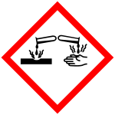 |  | Corrosive | 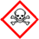 |  | Acute Toxic
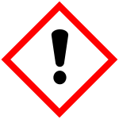 | X | Harmful / Irritant / Skin Sensitiser | 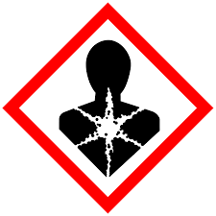 |  | Carcinogen / Germ Cell Mutagen / Reproductive Toxin | 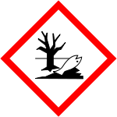 | X | Hazardous to the Aquatic Environment

Hazard Type
X

Gas Vapour Mist Fume Dust Liquid Solid Other (State)
Route of Exposure
X
X
X
X

Inhalation Skin Eyes Ingestion Other (State)
Workplace Exposure Limits (WELs) please indicate n/a where not applicable
Long-term exposure level (8hrTWA):  Sodium hydroxide 2mg/m3  Formic acid 5ppm 9.4mg/m3 |  |  |  |  |  |  | Short-term exposure level (15 mins):  Sodium hydroxide  Formic acid 10ppm 19mg/m3
State the Risks to Health from Identified Hazards
EC Classification:
R36/38 Irritating to eyes and skin
S2 Keep out of the reach of children S24/25 Avoid contact with skin and eyes. S26 In case of contact with eyes, rinse immediately with plenty of water and seek medical advice. S28 After contact with skin, wash immediately with plenty of water. S35 This material and its container must be disposed of in a safe way S46 If swallowed, seek medical advice immediately and show this container or label. S50 Do not mix with drain cleaners and bleach products. S51 Use only in well ventilated areas
Control Measures:
Use in well ventilated areas

Is health surveillance or monitoring required?
X

Yes No

Personal Protective Equipment (state type and standard)
Dust mask |  |  |  |  |  | Visor
Respirator |  |  |  |  |  | Goggles
Gloves |  | Gloves must be worn |  |  |  | Overalls
X  Footwear |  |  |  |  |  | Other
First Aid Measures
Inhalation:

Move affected person to fresh air and keep warm and at rest in a position comfortable for breathing

Skin:

Wash with plenty of water.

Eyes:

Rinse immediately with plenty of water. Remove any contact lenses and open eyelids wide apart. Continue to rinse for at least 15 minutes. Get medical attention if any discomfort continues.

Ingestion:

Do not induce vomiting. Give plenty of water to drink. Get medical attention if any discomfort continues.

Storage
Storage:

Avoid contact with skin and eyes. Avoid breathing vapour.

Storage Store in a cool dry area out of direct sunlight.

Disposal of Substances & Contaminated Containers
X

Hazardous Waste Skip Return to Depot Return to Supplier Other

(If Other Please State):
Is exposure adequately controlled? |  |  |  |  | X  Yes No
Risk Rating Following Control Measures
X

High Medium Low

Assessed by: Pete Reynolds Date: Review Date:

