COSHH Risk Assessment No: 00
Product Name: Liquid Bleach
Company name: Various Suppliers |  |  |  |  |  |  |  | Dept. (if applicable): N/A
Describe the activity or work process.  (Inc. how long/ how often this is carried out and quantity substance used) |  |  | Used as a cleaning agent
Location of process being carried out? |  |  | Kitchens/Toilets
Identify the persons at risk: |  |  |  | Employees  X |  |  |  |  | Sub-contractors |  | Public
Name the substance involved in the process and its manufacturer.  (A copy of a current safety data sheet is attached to this assessment) |  |  |  | Various Suppliers
Classification (state the category of danger)
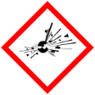 |  | Explosive | 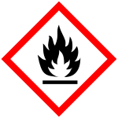 |  | Flammable | 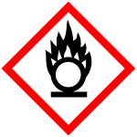 |  | Oxidising
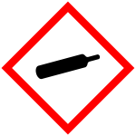 |  | Gas under pressure | 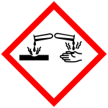 | X | Corrosive | 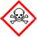 |  | Acute Toxic
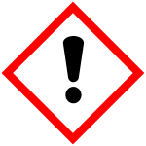 | X | Harmful / Irritant / Skin Sensitiser | 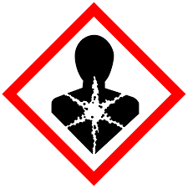 |  | Carcinogen / Germ Cell Mutagen / Reproductive Toxin | 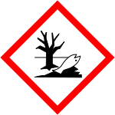 | X | Hazardous to the Aquatic Environment

Hazard Type
X

X
X

Gas Vapour Mist Fume Dust Liquid Solid Other (State)
Route of Exposure
X
X
X
X

Inhalation Skin Eyes Ingestion Other (State)
Workplace Exposure Limits (WELs) please indicate n/a where not applicable
Long-term exposure level (8hrTWA):  Sodium Hypochlorite 1.5 mg/m3 |  |  |  |  |  |  | Short-term exposure level (15 mins):
State the Risks to Health from Identified Hazards
EC Classification:

R31 Contact with acids liberates toxic gas.

S1/2 Keep locked up and out of the reach of children. S24/25 Avoid contact with skin and eyes. S46 If swallowed, seek medical advice immediately and show this container or label. S50 Do not mix with acid

H314 Causes severe skin burns and eye damage. H400 Very toxic to aquatic life.
Control Measures:
Use in well ventilated areas

Is health surveillance or monitoring required?
X

Yes No

Personal Protective Equipment (state type and standard)
Dust mask |  |  |  |  |  | Visor
X  Respirator |  |  |  |  |  | Goggles |  |  |  | If there is a risk of splashing, wear eye protection
Gloves |  | Use protective gloves. |  |  |  | Overalls
X  Footwear |  |  |  |  |  | Other
First Aid Measures
Inhalation:

Move affected person to fresh air and keep warm and at rest in a position comfortable for breathing

Skin:

Wash with plenty of water.

Eyes:

Rinse immediately with plenty of water. Remove any contact lenses and open eyelids wide apart. Continue to rinse for at least 15 minutes. Get medical attention if any discomfort continues.

Ingestion:

Do not induce vomiting. Give plenty of water to drink. Get medical attention if any discomfort continues.

Storage
Storage:

Store at moderate temperatures in dry, well ventilated area

Disposal of Substances & Contaminated Containers
X

Hazardous Waste Skip Return to Depot Return to Supplier Other

(If Other Please State):
Is exposure adequately controlled? |  |  |  |  | X  Yes No
Risk Rating Following Control Measures
X

High Medium Low

Assessed by: Pete Reynolds Date: Review Date:

