COSHH Risk Assessment No: 008
Product Name: Flash Clean & Bleach Kitchen & Bathroom Spray
Company name: Proctor & Gamble |  |  |  |  |  |  |  | Dept. (if applicable): N/A
Describe the activity or work process.  (Inc. how long/ how often this is carried out and quantity substance used) |  |  | Used as a surface cleaner
Location of process being carried out? |  |  | All areas
Identify the persons at risk: |  |  |  | Employees  X |  |  |  |  | Sub-contractors |  | Public
Name the substance involved in the process and its manufacturer.  (A copy of a current safety data sheet is attached to this assessment) |  |  |  | Flash Clean & Bleach Kitchen & Bathroom Spray  Procter & Gamble UK Brooklands, Weybridge, Surrey, KT13 0XP, UK  Tel: 01932 896000
Classification (state the category of danger)
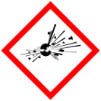 |  | Explosive | 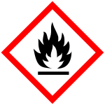 |  | Flammable | 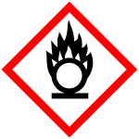 |  | Oxidising
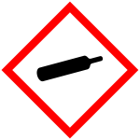 |  | Gas under pressure | 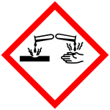 |  | Corrosive | 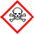 |  | Acute Toxic
 | X | Harmful / Irritant / Skin Sensitiser | 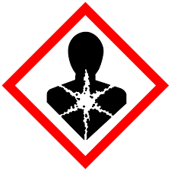 |  | Carcinogen / Germ Cell Mutagen / Reproductive Toxin | 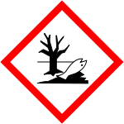 | X | Hazardous to the Aquatic Environment

Hazard Type
X

X
X

Gas Vapour Mist Fume Dust Liquid Solid Other (State)
Route of Exposure
X
X
X
X

Inhalation Skin Eyes Ingestion Other (State)
Workplace Exposure Limits (WELs) please indicate n/a where not applicable
Long-term exposure level (8hrTWA): |  |  |  |  |  |  | Short-term exposure level (15 mins):
State the Risks to Health from Identified Hazards
EC Classification:
H314 Causes severe skin burns and eye damage H315 Causes skin irritation H318 Causes serious eye damage
H400 Very toxic to aquatic life
S26 In case of contact with eyes, rinse immediately with plenty of water and seek medical advice S46 If swallowed, seek medical advice immediately and show the container or label
R31 Contact with acids liberates toxic gas R34 Causes burns R36/37/38 Irritating to eyes, respiratory system and skin
R38 Irritating to skin R41 Risk of serious damage to eyes R50 Very toxic to aquatic organisms

Control Measures:
Use in well ventilated areas
Is health surveillance or monitoring required?
X

Yes No

Personal Protective Equipment (state type and standard)
Dust mask |  |  |  |  |  | Visor
Respirator |  |  |  |  |  | Goggles
Gloves |  | Gloves must be worn |  |  |  | Overalls
X  Footwear |  |  |  |  |  | Other
First Aid Measures
Inhalation:

Move affected person to fresh air and keep warm and at rest in a position comfortable for breathing

Skin:

Wash with plenty of water.

Eyes:

Rinse immediately with plenty of water. Remove any contact lenses and open eyelids wide apart. Continue to rinse for at least 15 minutes. Get medical attention if any discomfort continues.

Ingestion:

Do not induce vomiting. Give plenty of water to drink. Get medical attention if any discomfort continues.

Storage
Storage:

Avoid contact with skin and eyes.

Storage Store in a cool dry area out of direct sunlight.

Disposal of Substances & Contaminated Containers
X

Hazardous Waste Skip Return to Depot Return to Supplier Other

(If Other Please State):
Is exposure adequately controlled? |  |  |  |  | X  Yes No
Risk Rating Following Control Measures
X

High Medium Low

Assessed by: Pete Reynolds Date: Review Date:

