COSHH Risk Assessment No: 00
Product Name: WD40
Company name: WD40 Company Ltd UK |  |  |  |  |  |  |  | Dept. (if applicable): N/A
Describe the activity or work process.  (Inc. how long/ how often this is carried out and quantity substance used) |  |  | Used as a penetrating oil
Location of process being carried out? |  |  | Within the building
Identify the persons at risk: |  |  |  | Employees  X |  |  |  |  | Sub-contractors |  | Public
Name the substance involved in the process and its manufacturer.  (A copy of a current safety data sheet is attached to this assessment) |  |  |  | WD40  WD40 Company Ltd UK, Kiln Farm, Milton Keynes, MK11 3LF Tel 01908 266900
Classification (state the category of danger)
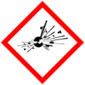 |  | Explosive | 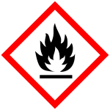 | X | Flammable | 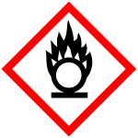 |  | Oxidising
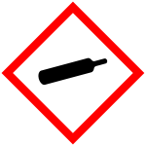 |  | Gas under pressure | 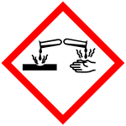 |  | Corrosive | 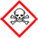 |  | Acute Toxic
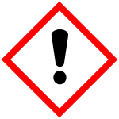 | X | Harmful / Irritant / Skin Sensitiser | 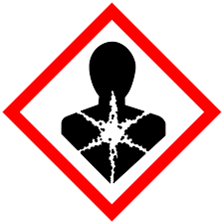 |  | Carcinogen / Germ Cell Mutagen / Reproductive Toxin | 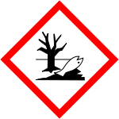 |  | Hazardous to the Aquatic Environment

Hazard Type
X

X
X

Gas Vapour Mist Fume Dust Liquid Solid Other (State)
Route of Exposure
X
X
X
X

Inhalation Skin Eyes Ingestion Other (State)
Workplace Exposure Limits (WELs) please indicate n/a where not applicable
Long-term exposure level (8hrTWA):  Hydrocarbons 800 mg/m3  Oil mists 5 mg/m3 |  |  |  |  |  |  | Short-term exposure level (15 mins):  Oil mists 10 mg/m3
State the Risks to Health from Identified Hazards
EC Classification: Flammable

R10 Flammable.
R65 Harmful: may cause lung damage if swallowed
R66 Repeated exposure may cause skin dryness or cracking.
R67 Vapours may cause drowsiness and dizziness.

Control Measures:
Use in well ventilated areas

Is health surveillance or monitoring required?
X

Yes No

Personal Protective Equipment (state type and standard)
Dust mask |  |  |  |  |  | Visor
Respirator |  | Use in a well-ventilated area |  |  |  | Goggles
X  Gloves |  | No specific hand protection recommended. For prolonged or repeated skin contact use suitable protective gloves. |  |  |  | Overalls
X  Footwear |  |  |  |  |  | Other
First Aid Measures

Inhalation:
If spray/mist has been inhaled, Move affected person to fresh air and keep warm and at rest in a position comfortable for breathing

Skin:
Wash with plenty of water.

Eyes:
Rinse immediately with plenty of water. Remove any contact lenses and open eyelids wide apart. Continue to rinse for at least 15 minutes. Get medical attention if any discomfort continues.

Ingestion:
Do not induce vomiting. Give plenty of water to drink. Get medical attention if any discomfort continues.

Storage
Keep only in the original container in a cool, well-ventilated place.

Store away from the following materials: Oxidising materials.

Disposal of Substances & Contaminated Containers
X

Hazardous Waste Skip Return to Depot Return to Supplier Other

(If Other Please State):
Is exposure adequately controlled? |  |  |  |  | X  Yes No
Risk Rating Following Control Measures
X

High Medium Low

Assessed by: Pete Reynolds Date: Review Date:

