COSHH Risk Assessment No: 0
Product Name: DETTOL Complete Clean Antibacterial Mould & Mildew
Company name: Reckitt Benckiser |  |  |  |  |  |  |  | Dept. (if applicable): N/A
Describe the activity or work process.  (Inc. how long/ how often this is carried out and quantity substance used) |  |  | Used to remove mould & mildew stains
Location of process being carried out? |  |  | All areas requiring removal of mould & mildew stains
Identify the persons at risk: |  |  |  | Employees  X |  |  |  |  | Sub-contractors |  | Public
Name the substance involved in the process and its manufacturer.  (A copy of a current safety data sheet is attached to this assessment) |  |  |  | DETTOL Complete Clean Antibacterial Mould & Mildew  Reckitt Benckiser Wellcroft House Wellcroft Road Slough, Berkshire SL1 4AQ Tel 0845 769 7079
Classification (state the category of danger)
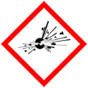 |  | Explosive | 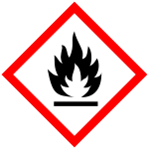 |  | Flammable | 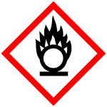 | X | Oxidising
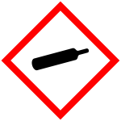 |  | Gas under pressure | 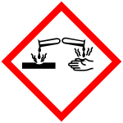 | X | Corrosive | 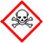 |  | Acute Toxic
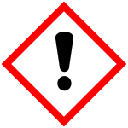 | X | Harmful / Irritant / Skin Sensitiser | 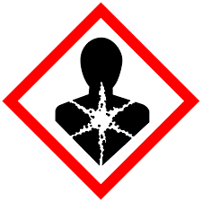 |  | Carcinogen / Germ Cell Mutagen / Reproductive Toxin | 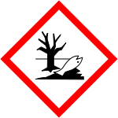 | X | Hazardous to the Aquatic Environment

Hazard Type
X

X
X

Gas Vapour Mist Fume Dust Liquid Solid Other (State)
Route of Exposure
X
X
X
X

Inhalation Skin Eyes Ingestion Other (State)
Workplace Exposure Limits (WELs) please indicate n/a where not applicable
Long-term exposure level (8hrTWA): |  |  |  |  |  |  | Short-term exposure level (15 mins):
State the Risks to Health from Identified Hazards
EC Classification: Irritant
R36/38: Irritating to eyes and skin R31:Contact with acids liberates toxic gas R34: Causes burns R50:Very toxic to aquatic organisms
S2: Keep out of reach of children S23: Do not breathe vapour S26: In case of contact with eyes, rinse immediately with plenty of water and seek medical advice S28: After contact with skin, wash immediately with plenty of water S35: This material and its container must be disposed of in a safe way S46: If swallowed, seek medical advice immediately and show the container or label S51: Use only in well ventilated areas S24/25: Avoid contact with skin and eyes
H314: Causes severe skin burns and eye damage H400: Very toxic to aquatic life

Control Measures:
Use in well ventilated areas

Is health surveillance or monitoring required?
X

Yes No

Personal Protective Equipment (state type and standard)
Dust mask |  |  |  |  |  | Visor
X  Respirator |  |  |  |  |  | Goggles |  |  |  | Wear suitable eye protection
Gloves |  | Gloves must be worn |  |  |  | Overalls
X  Footwear |  |  |  |  |  | Other
First Aid Measures
Inhalation:

Move affected person to fresh air and keep warm and at rest in a position comfortable for breathing if symptoms persist seek medical advice

Skin:

After contact with skin, wash with plenty of water; if symptoms persist seek medical advice.

Eyes:

Rinse immediately with plenty of water. Remove any contact lenses and open eyelids wide apart. Continue to rinse for at least 15 minutes. Get medical attention if any discomfort continues.

Ingestion:

Do not induce vomiting. Give plenty of water to drink. Get medical attention if any discomfort continues.

Storage
Storage:

Avoid contact with skin and eyes.

Storage Store in a cool dry area out of direct sunlight.

Disposal of Substances & Contaminated Containers
X

Hazardous Waste Skip Return to Depot Return to Supplier Other

(If Other Please State):
Is exposure adequately controlled? |  |  |  |  | X  Yes No
Risk Rating Following Control Measures
X

High Medium Low

Assessed by: Pete Reynolds Date: Review Date:

