COSHH Risk Assessment No:
Product Name: Finish Dishwasher Rinse Aid
Company name: Reckitt Benckiser |  |  |  |  |  |  |  | Dept. (if applicable): N/A
Describe the activity or work process.  (Inc. how long/ how often this is carried out and quantity substance used) |  |  | Used as a rinse aid in dishwashers
Location of process being carried out? |  |  | Kitchen Area
Identify the persons at risk: |  |  |  | Employees  X |  |  |  |  | Sub-contractors |  | Public
Name the substance involved in the process and its manufacturer.  (A copy of a current safety data sheet is attached to this assessment) |  |  |  | Finish Dishwasher Rinse Aid  Reckitt Benckiser Wellcroft House Wellcroft Road Slough, Berkshire SL1 4AQ
Classification (state the category of danger)
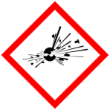 |  | Explosive | 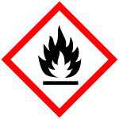 |  | Flammable | 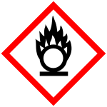 |  | Oxidising
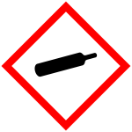 |  | Gas under pressure | 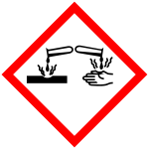 |  | Corrosive | 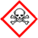 |  | Acute Toxic
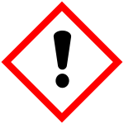 | X | Harmful / Irritant / Skin Sensitiser | 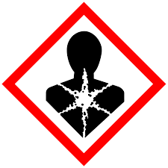 |  | Carcinogen / Germ Cell Mutagen / Reproductive Toxin | 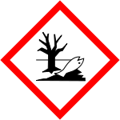 | X | Hazardous to the Aquatic Environment

Hazard Type
X

Gas Vapour Mist Fume Dust Liquid Solid Other (State)
Route of Exposure
X
X
X
X

Inhalation Skin Eyes Ingestion Other (State)
Workplace Exposure Limits (WELs) please indicate n/a where not applicable
Long-term exposure level (8hrTWA): |  |  |  |  |  |  | Short-term exposure level (15 mins):
State the Risks to Health from Identified Hazards
EC Classification: Irritant
R22: Harmful if swallowed R36: Irritating to eyes R36/38: Irritating to eyes and skin R41: Risk of serious damage to eyes R50: Very toxic to aquatic organisms
S2: Keep out of reach of children S26: In case of contact with eyes, rinse immediately with plenty of water and seek medical advice S35: This material and its container must be disposed of in a safe way S46: If swallowed, seek medical advice immediately and show the container or label
H302: Harmful if swallowed H315: Causes skin irritation H318 Causes serious eye damage H319: Causes serious eye irritation H400: Very toxic to aquatic life
Control Measures:
Use in well ventilated areas

Is health surveillance or monitoring required?
X

Yes No

Personal Protective Equipment (state type and standard)
Dust mask |  |  |  |  |  | Visor
Respirator |  |  |  |  |  | Goggles |  |  |  | Avoid contact with eyes
Gloves |  | Avoid contact with skin |  |  |  | Overalls
Footwear |  |  |  |  |  | Other
First Aid Measures

Inhalation

Remove victim immediately from source of exposure. Move the exposed person to fresh air at once. Get medical attention if any discomfort continues.

Ingestion

Immediately rinse mouth and provide fresh air. Promptly get affected person to drink large volumes of water to dilute the swallowed chemical. Do not induce vomiting. If vomiting occurs, the head should be kept low so that stomach vomit doesn't enter the lungs. Get medical attention immediately!

Skin contact

Remove contaminated clothing immediately and wash skin with soap and water.

Eye contact

Promptly wash eyes with plenty of water while lifting the eye lids. Continue to rinse for at least 15 minutes and get medical attention.

Storage
Store in tightly closed original container in a dry and cool place.

Disposal of Substances & Contaminated Containers
X

Hazardous Waste Skip Return to Depot Return to Supplier Other

(If Other Please State):
Is exposure adequately controlled? |  |  |  |  | X  Yes No
Risk Rating Following Control Measures
X

High Medium Low

Assessed by: Pete Reynolds Date: Review Date:

