COSHH Risk Assessment No: 001
Product Name: Cif Floor Cleaner Ocean
Company name: Unilever UK Limited |  |  |  |  |  |  |  | Dept. (if applicable): N/A
Describe the activity or work process.  (Inc. how long/ how often this is carried out and quantity substance used) |  |  | Used as a floor cleaning agent
Location of process being carried out? |  |  | All areas
Identify the persons at risk: |  |  |  | Employees  X |  |  |  |  | Sub-contractors |  | Public
Name the substance involved in the process and its manufacturer.  (A copy of a current safety data sheet is attached to this assessment) |  |  |  | Cif Floor Cleaner Ocean  Unilever UK Limited, Springfield Drive, Leatherhead, Surrey  KT22 7GR 0800 77 66 46
Classification (state the category of danger)
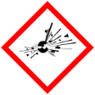 |  | Explosive | 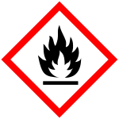 |  | Flammable | 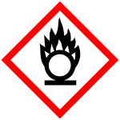 |  | Oxidising
 |  | Gas under pressure | 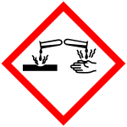 |  | Corrosive | 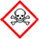 |  | Acute Toxic
 | X | Harmful / Irritant / Skin Sensitiser | 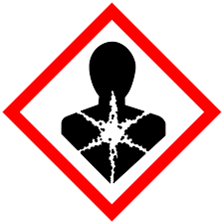 |  | Carcinogen / Germ Cell Mutagen / Reproductive Toxin | 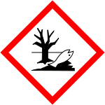 |  | Hazardous to the Aquatic Environment

Hazard Type
X

X

Gas Vapour Mist Fume Dust Liquid Solid Other (State)
Route of Exposure
X
X
X
X

Inhalation Skin Eyes Ingestion Other (State)
Workplace Exposure Limits (WELs) please indicate n/a where not applicable
Long-term exposure level (8hrTWA): |  |  |  |  |  |  | Short-term exposure level (15 mins):
State the Risks to Health from Identified Hazards
EC Classification:

R22 Harmful if swallowed. R41 Risk of serious damage to eyes. AISE 1 Keep away from children. AISE 2 Keep away from eyes. If product gets into eyes rinse thoroughly with water.
Control Measures:
Use in well ventilated areas

Is health surveillance or monitoring required?
X

Yes No

Personal Protective Equipment (state type and standard)
Dust mask |  |  |  |  |  | Visor
Respirator |  |  |  |  |  | Goggles
Gloves |  | Gloves must be worn |  |  |  | Overalls
X  Footwear |  |  |  |  |  | Other
First Aid Measures
Inhalation:

Move affected person to fresh air and keep warm and at rest in a position comfortable for breathing

Skin:

Wash with plenty of water.

Eyes:

Rinse immediately with plenty of water. Remove any contact lenses and open eyelids wide apart. Continue to rinse for at least 15 minutes. Get medical attention if any discomfort continues.

Ingestion:

Do not induce vomiting. Give plenty of water to drink. Get medical attention if any discomfort continues.

Storage
Storage:

Keep away from heat, sparks and open flame.

Keep in original container. Store at moderate temperatures in dry, well ventilated area.

Disposal of Substances & Contaminated Containers
X

Hazardous Waste Skip Return to Depot Return to Supplier Other

(If Other Please State):
Is exposure adequately controlled? |  |  |  |  | X  Yes No
Risk Rating Following Control Measures
X

High Medium Low

Assessed by: Pete Reynolds Date: Review Date:

