COSHH Risk Assessment No: 0
Product Name: Toilet Duck Toilet Cleaner
Company name: Diversy Ltd |  |  |  |  |  |  |  | Dept. (if applicable): N/A
Describe the activity or work process.  (Inc. how long/ how often this is carried out and quantity substance used) |  |  | Used as a toilet cleaner
Location of process being carried out? |  |  | All areas
Identify the persons at risk: |  |  |  | Employees  X |  |  |  |  | Sub-contractors |  | Public
Name the substance involved in the process and its manufacturer.  (A copy of a current safety data sheet is attached to this assessment) |  |  |  | Toilet Duck Toilet Cleaner  Diversy Ltd, Weston Favell Centre, Northampton NN3 8PD
Classification (state the category of danger)
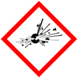 |  | Explosive | 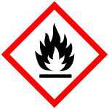 |  | Flammable | 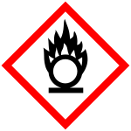 |  | Oxidising
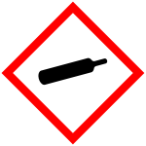 |  | Gas under pressure | 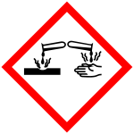 |  | Corrosive | 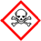 |  | Acute Toxic
 | X | Harmful / Irritant / Skin Sensitiser | 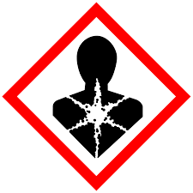 |  | Carcinogen / Germ Cell Mutagen / Reproductive Toxin | 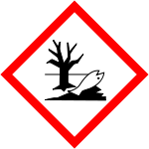 | X | Hazardous to the Aquatic Environment

Hazard Type
X

Gas Vapour Mist Fume Dust Liquid Solid Other (State)
Route of Exposure
X
X
X
X

Inhalation Skin Eyes Ingestion Other (State)
Workplace Exposure Limits (WELs) please indicate n/a where not applicable
Long-term exposure level (8hrTWA): |  |  |  |  |  |  | Short-term exposure level (15 mins):
State the Risks to Health from Identified Hazards
EC Classification:

R22 - Harmful if swallowed. R38 - Irritating to skin. R41 - Risk of serious damage to eyes. R50 - Very toxic to aquatic organisms.

Control Measures:
Use in well ventilated areas

Is health surveillance or monitoring required?
X

Yes No

Personal Protective Equipment (state type and standard)
Dust mask |  |  |  |  |  | Visor
X  Respirator |  |  |  |  |  | Goggles |  |  |  | Avoid contact with eyes
Gloves |  | Gloves must be worn |  |  |  | Overalls
X  Footwear |  |  |  |  |  | Other
First Aid Measures

Inhalation:

Move affected person to fresh air and keep warm and at rest in a position comfortable for breathing

Skin:

Not required under normal use. Immediately wash off with plenty of water. If irritation develops get medical attention

Eyes:

Rinse immediately with plenty of water. Remove any contact lenses and open eyelids wide apart. Continue to rinse for at least 15 minutes. Get medical attention if any discomfort continues.

Ingestion:

Do not induce vomiting. Give plenty of water to drink. Get medical attention if any discomfort continues.

Storage
Storage:

Storage Store in a cool dry area out of direct sunlight in original container.

Disposal of Substances & Contaminated Containers
X

Hazardous Waste Skip Return to Depot Return to Supplier Other

(If Other Please State):
Is exposure adequately controlled? |  |  |  |  | X  Yes No
Risk Rating Following Control Measures
X

High Medium Low

Assessed by: Pete Reynolds Date: Review Date:

