COSHH Risk Assessment No: 0
Product Name: Air Freshener
Company name: Various Suppliers |  |  |  |  |  |  |  | Dept. (if applicable): N/A
Describe the activity or work process.  (Inc. how long/ how often this is carried out and quantity substance used) |  |  | Used as an Air Freshener
Location of process being carried out? |  |  | All areas
Identify the persons at risk: |  |  |  | Employees  X |  |  |  |  | Sub-contractors |  | Public
Name the substance involved in the process and its manufacturer.  (A copy of a current safety data sheet is attached to this assessment) |  |  |  | Air Freshener  Various Suppliers
Classification (state the category of danger)
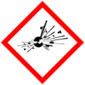 |  | Explosive | 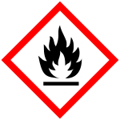 | X | Flammable | 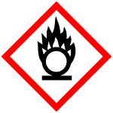 |  | Oxidising
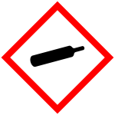 |  | Gas under pressure | 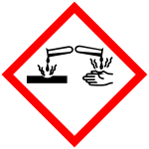 |  | Corrosive | 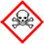 |  | Acute Toxic
 | X | Harmful / Irritant / Skin Sensitiser | 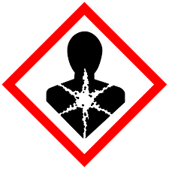 |  | Carcinogen / Germ Cell Mutagen / Reproductive Toxin | 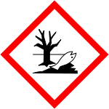 |  | Hazardous to the Aquatic Environment

Hazard Type
X
X

Gas Vapour Mist Fume Dust Liquid Solid Other (State)
Route of Exposure
X
X
X
X

Inhalation Skin Eyes Ingestion Other (State)
Workplace Exposure Limits (WELs) please indicate n/a where not applicable
Long-term exposure level (8hrTWA):  BUTANE 600 ppm 1450 mg/m3  PROPAN-2-OL 400 ppm 999 mg/m3 |  |  |  |  |  |  | Short-term exposure level (15 mins):  BUTANE 750 ppm 1810 mg/m3  PROPAN-2-OL 500 ppm 1250 mg/m3
State the Risks to Health from Identified Hazards
EC Classification:

R12 Extremely flammable. R22 Harmful if swallowed. R11 Highly flammable R36 Irritating to eyes. R41 Risk of serious damage to eyes. R67 Vapours may cause drowsiness and dizziness.

S9 Keep container in a well-ventilated place. S16 Keep away from sources of ignition - No smoking. S51 Use only in well-ventilated areas. S60 This material and its container must be disposed of as hazardous waste.

H319 Causes serious eye irritation. H220 Extremely flammable gas. H225 Highly flammable liquid and vapour.
H336 May cause drowsiness or dizziness.
Control Measures:
Use in well ventilated areas

Is health surveillance or monitoring required?
X

Yes No

Personal Protective Equipment (state type and standard)
Dust mask |  |  |  |  |  | Visor
Respirator |  |  |  |  |  | Goggles |  |  |  | Avoid contact with eyes
Gloves |  | Avoid contact with skin |  |  |  | Overalls
X  Footwear |  |  |  |  |  | Other
First Aid Measures
Inhalation:

Remove from site of exposure into fresh air. Keep warm and at rest. Obtain medical attention immediately if breathing
shows signs of failing

Skin:

Immediately wash the skin thoroughly with plenty of clean water. If redness or irritation persists, obtain medical advice..

Eyes:

Immediately wash the eye with plenty of water for at least 10 minutes, holding the eye open. Remove from site of exposure. If redness or irritation persists, obtain medical advice. Protect uninjured eye.

Ingestion:

Promptly get affected person to drink large volumes of water to dilute the swallowed chemical. DO NOT induce vomiting. Get medical attention immediately.

Storage
Storage:

Store in tightly-closed, original container in a dry, cool and well-ventilated place.

Disposal of Substances & Contaminated Containers
X

Hazardous Waste Skip Return to Depot Return to Supplier Other

(If Other Please State):
Is exposure adequately controlled? |  |  |  |  | X  Yes No
Risk Rating Following Control Measures
X

High Medium Low

Assessed by: Pete Reynolds Date: Review Date:

